TASKS ON PARAMETER STORE
Task Title:
Create a parameter and access via ec2
Step by Step Implementation:

Navigate to Parameter store on aws and click on create parameter
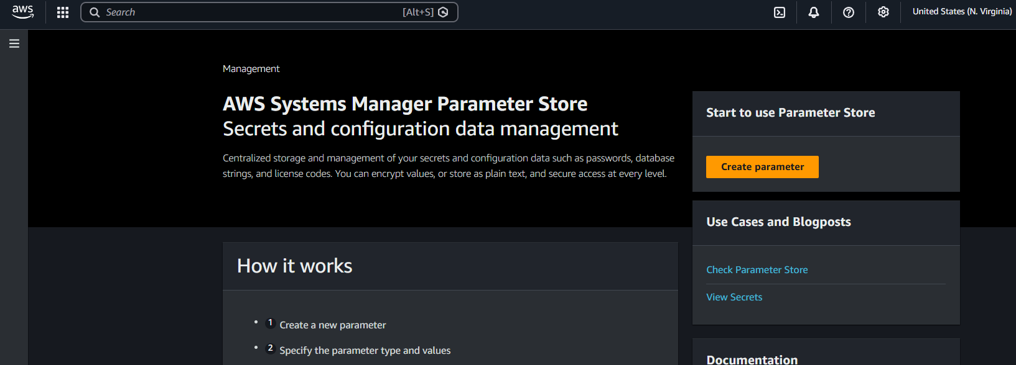
Provide the parameter name and select the TIER
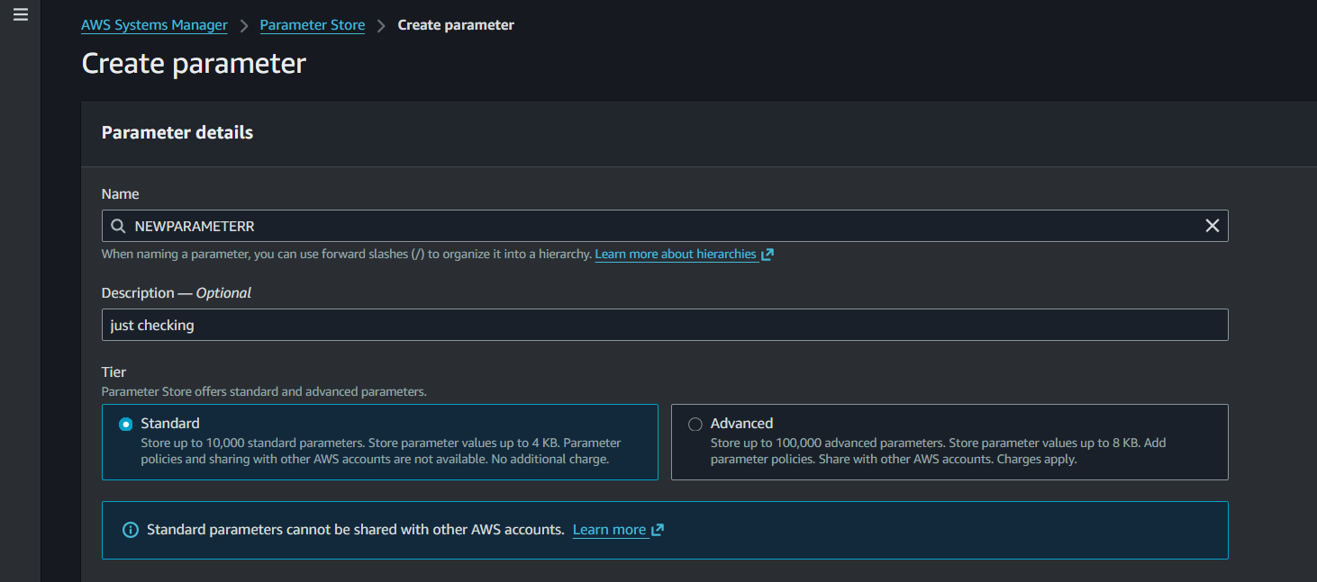

Select the STRING and Enter the Value means secret value and click on create parameter
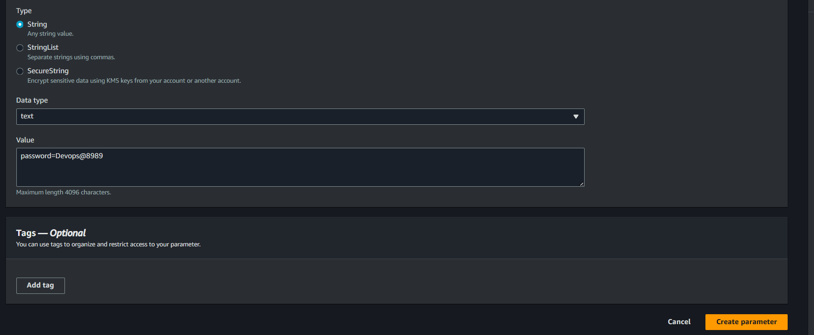
New parameter had been created
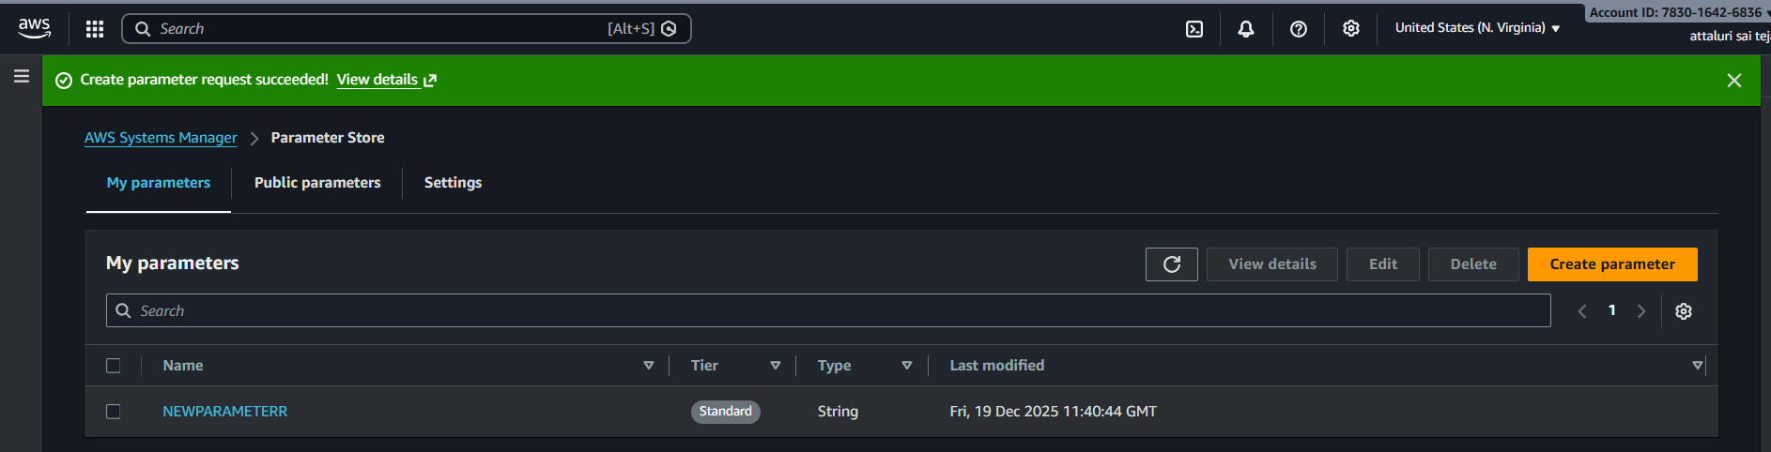
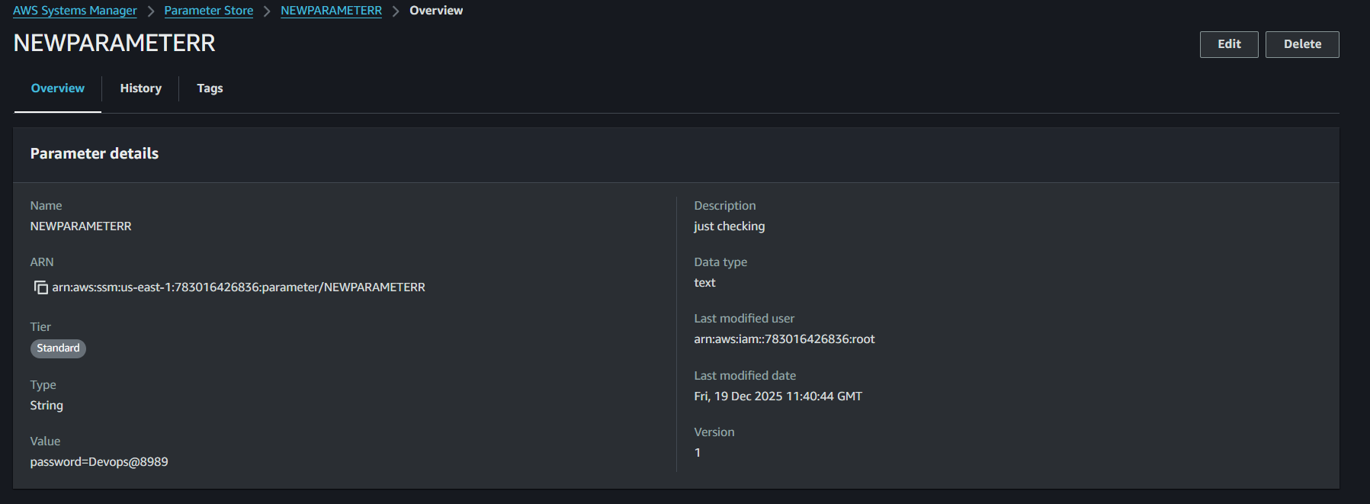
Checking the versions and its only one because we didn’t made any changes
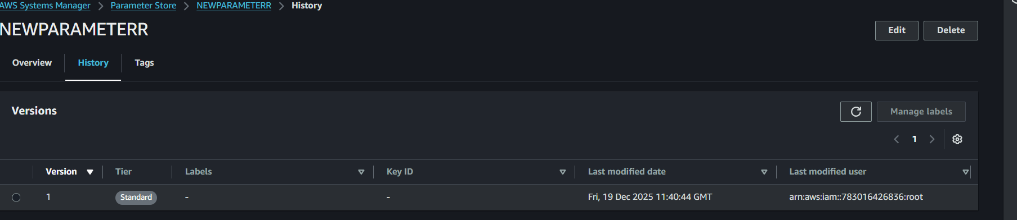

And made changes in the password using edit options and reverified and versions are available in two.
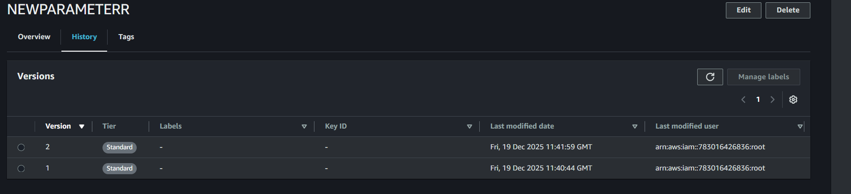
Create a IAM role and attach it to EC2
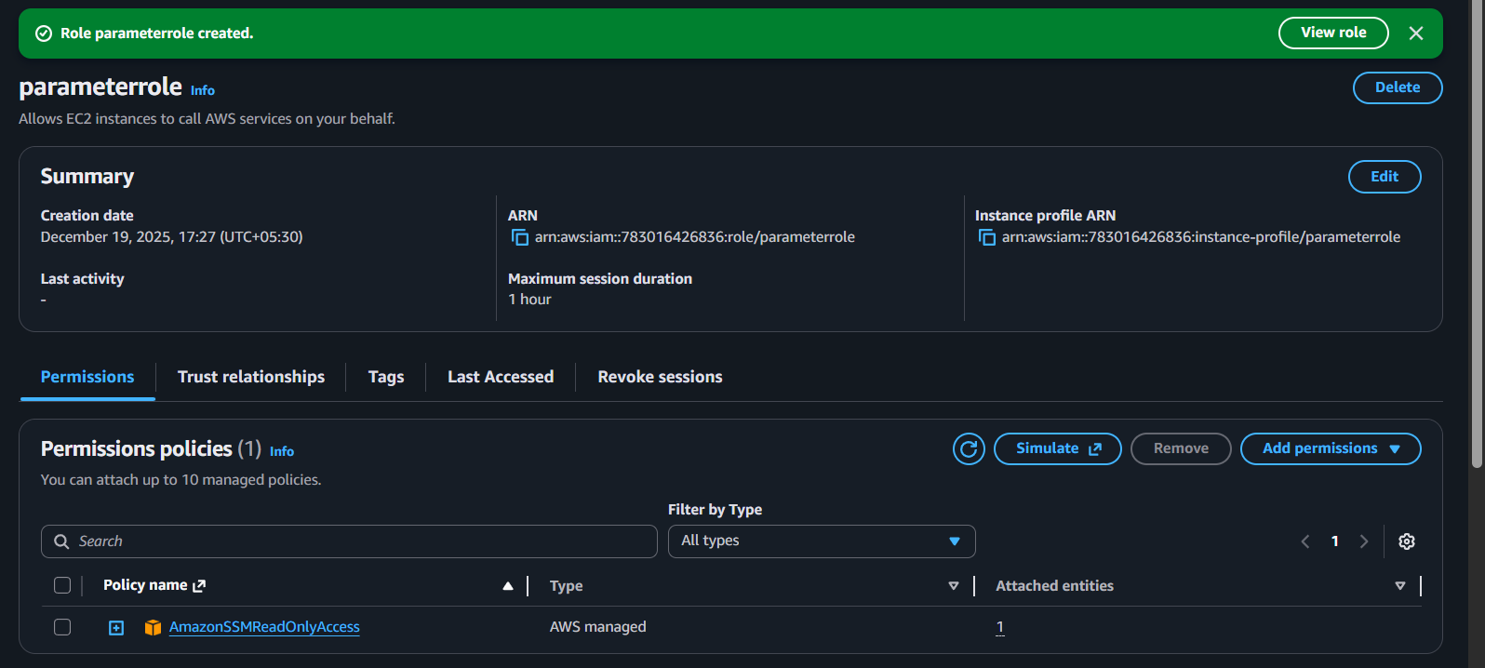
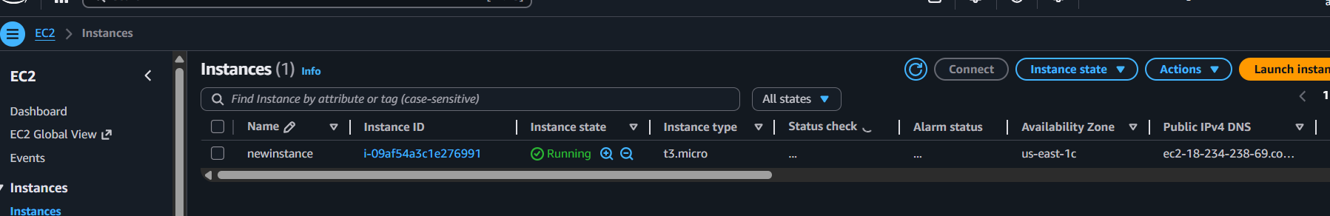
Role has been attached to EC2
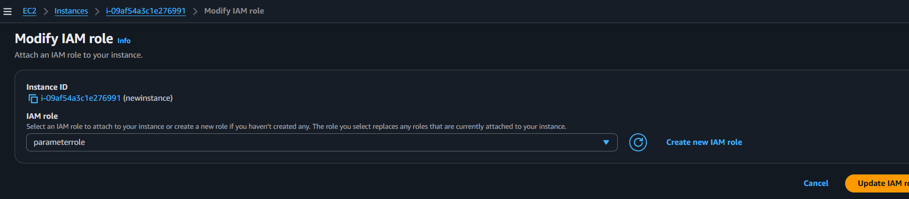

Validation Part::
Connect EC2 via SSH or in browser
Command::: for only Value
aws ssm get-parameter \
--name "NEWPARAMETERR" \
--query "Parameter.Value" \
--output text
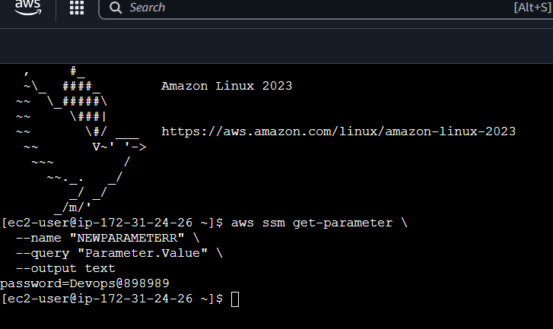
If you want to fetch multiple parameters by path
aws ssm get-parameters-by-path \
--path "/" \
--recursive \
--with-decryption \
--query "Parameters[].{Name:Name,Value:Value}"
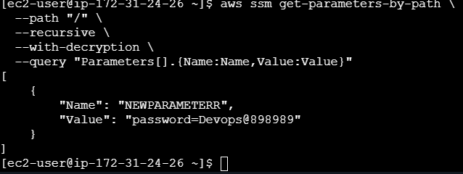

Conclusion::
Created a parameter and successfully validated via ec2

